Project 2: SQL server

Adit Chakraborty

Requirements/Deliverables

To test your skills in **Section 1:** We will test you on DDL and DML

T-SQL comes with two broad categories of statements.

1). Data Manipulation/Modification Language (DML), such as INSERT, UPDATE, DELETE.

2). Data Definition Language (DDL), such as CREATE, ALTER, DROP.

* Create any two DDL and DML Statement.
* Provide 4 variations of SELECT Statement with WHERE clause.

-- Remap order dates to recent dates

-- SQL multiple value assignment

SQL drop table

To test your skills in **Section 2:**we will test you on JOINS, SET operators, and some aggregate functions.

1. Create two Joins statement for all four types of Joins that you have covered in this course.
2. Provides two examples of SET Operator

Hint: SQL joins tends to combine columns from different tables, whereas SQL set operators combine rows from distinct queries.

1. Pick any 5 aggregate functions of your choice.

Hint: Aggregate functions compute a single result from a set of input values.

Answer 1: SQL GROUP BY inner join - SQL group by count - sql group by clause

Answer 2: Basic SQL GROUP BY query - GROUPING on function expression - SUM aggregate function

To test your skills in **Section 3**: we will test you on Subqueries, APPLY, Table expressions, and Pivoting data.

1. Provides two example of CTE (Common Table Expressions) and compare it with regular Select statement.
2. Give two examples of Pivot that converts rows into columns.

Example 1)

SQL Pivot Example

To test your skills in **Section 4:**This section will expect you to put all of the Section 1-3 concepts and conclude with a mini-project. You will be using Transactions, Error handling and T-SQL Programming.

1. Provide one example of code that can raise error or an exception and then use the same example using Try Catch block to elaborate on the benefit of error handling.
2. While focusing on benefit of ACID, provides two examples of code with and without Transactions commands. Discuss the benefits of using Transactions.

Mini-Project- Create a Hotel Management System where each guest record is inserted with his purpose of stay. Based on that write queries that gives the Manager an idea about the type of guests, the hotel receives the most so hotel management can alter facilities and amenities in the hotel to increase the revenues by attracting more customers.

1. raise error or an exception handling

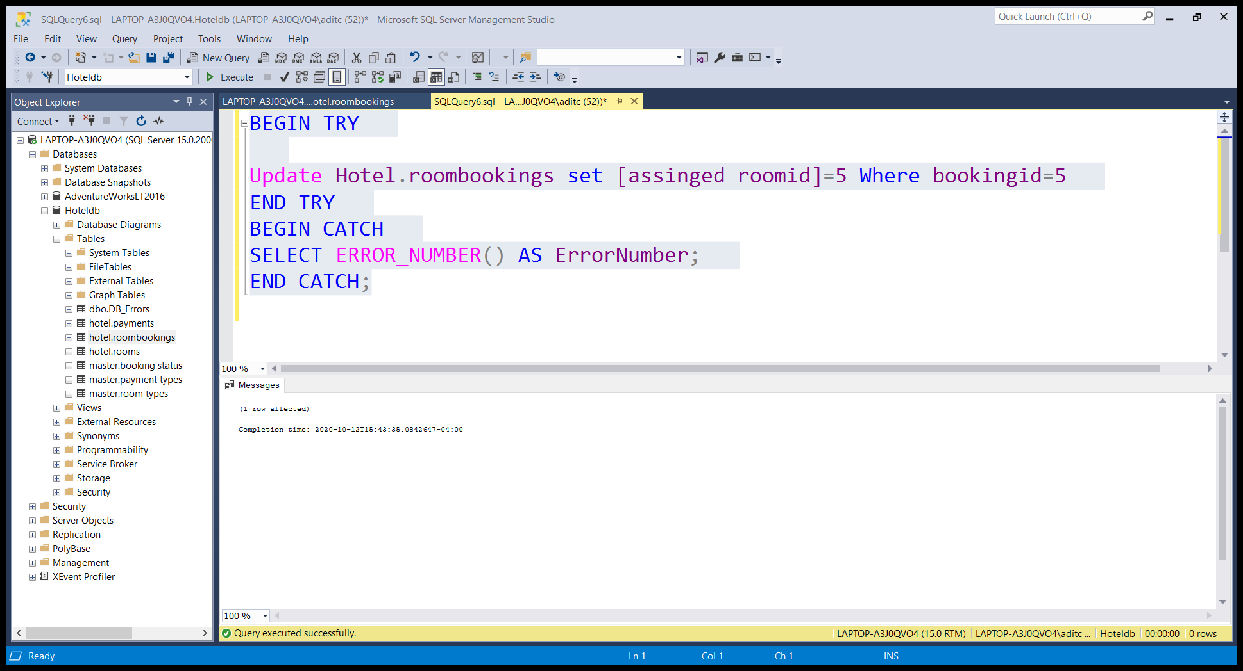

Discussion: what’s the benefit of transaction commands Many databases uses require storing data to multiple tables, or multiple rows to the same table in order to maintain a consistent data set. Using transactions ensures that other connections to the same database see either all the updates or none of them. This also applies in the case of interrupted connections.